First Approved | May 2017 | Initial Approval Body | eCampus NZ Board
Current Version | August 2022 | Responsibility | Ali Hughes - Learner Experience & Success Manager
Next Review | December 2022

Contents
1. Purpose 3
2. Scope 3
3. Formal Delegations 3
4. Definitions 3
5. Principles 4
6. Associated Procedures for the eCampus Policy on: Learner Concerns and Complaints 6
LEARNER COMPLAINT FORM 7
7. References 8
7.1 Internal 8
7.2 External 8

1. Purpose
eCampus NZ (part of Te Pūkengā's Open Polytechnic business division) provides services through its eCampus operations. The services include delivery of courses for Institutes of Technology and Polytechnics (ITPs) via an online delivery platform.
eCampus NZ (part of Te Pūkengā's Open Polytechnic business division) takes learner concerns and complaints seriously.
The purpose of this policy is to ensure that learner concerns and complaints are resolved in a timely, fair and equitable way and are part of a continuous process to improve service.

2. Scope
This policy, including associated procedures, applies to concerns and complaints raised by learners participating in the eCampus NZ (part of Te Pūkengā's Open Polytechnic business division) community, who may be enrolled in any of the participating ITPs.
A concern is about a matter that is affecting an individual, is important to them, that may be impacting on their learning, yet is not serious enough to be a formal complaint, and the person would like to have it resolved.
A complaint is a written adverse comment signed by the complainant. The complaint must contain sufficient detail to enable investigation
Ecampus NZ (part of Te Pūkengā's Open Polytechnic business division) reserves the right not to progress:
- Anonymous complaints or complaints based on hearsay.
- Complaints made more than 90 days after an alleged incident.
- Complaints where the complainant is not willing to provide sufficient information to achieve a resolution.

3. Formal Delegations
Ecampus NZ (part of Te Pūkengā's Open Polytechnic business division) Learner Experience & Success Manager can assist with interpretation or clarification of this policy and is authorised to make or approve exceptions to the policy.

4. Definitions

Advocate | A person who speaks on behalf of a complainant or a  respondent.
Complaint | A complaint made in writing using the Learner Complaint  Form (Refer Appendix One).
Complainant | The person who makes a complaint.
Concern | A written or verbal expression of dissatisfaction received from a learner which the learner does not wish to be escalated to a complaint
Learner | A learner enrolled through an ITP who is participating in the eCampus NZ (part of Te Pūkengā's Open Polytechnic business division) community, through the online delivery platform.
Mediation | A process by which a neutral, impartial and acceptable third party helps the disputing complainant and respondent to identify the issues in their dispute; to generate options; and consider alternatives so they can reach their own mutually acceptable solution.  The focus of mediation is on the future relationship between the parties, not on allocating blame for past differences. A mediator will respond quickly and confidentially when asked  to act and the aim of the process is to minimise disruption and stress.
Respondent | The person about whom a complaint is made.

5. Principles
eCampus NZ (part of Te Pūkengā's Open Polytechnic business division) provides a culture where it is safe for learners to voice their concerns and have them resolved in a timely, professional manner.
Wherever possible, concerns should be resolved by negotiation between the parties directly involved, with support, or through mediation. eCampus NZ (part of Te Pūkengā's Open Polytechnic business division) Advisors and eCampus NZ Learner Experience & Success Manager can assist in resolving concerns.
If there is no resolution, then the complaints procedure should be followed. Principles of natural justice are incorporated as outlined below:
- The respondent will be given all relevant information regarding the allegation, an opportunity to
prepare and present evidence, and to respond to the arguments provided.
- The person(s) deciding on the allegations will be impartial and make decisions based on a balanced and considered assessment of the information. Decisions regarding allegations are based on logical proof or evidence.
A complaint may be withdrawn by the complainant at any time. The complainant will be asked to provide a rationale for the decision. eCampus NZ (part of Te Pūkengā's Open Polytechnic business division) reserves the right to progress complaints when it considers it to be appropriate.
Complaints are to be resolved as quickly as possible.
Complainants and respondents need to be prepared to assist the resolution process (e.g. attend meetings and provide information requested).
At any stage of the process any complaint may be referred to mediation where there is agreement by the complainant to participate in mediation.
eCampus NZ (part of Te Pūkengā's Open Polytechnic business division) will keep the enrolling ITP fully informed if one of their learners submits an official complaint, and the progress and outcome of any such complaint.

6. Associated Procedures for the eCampus Policy on: Learner Concerns and Complaints
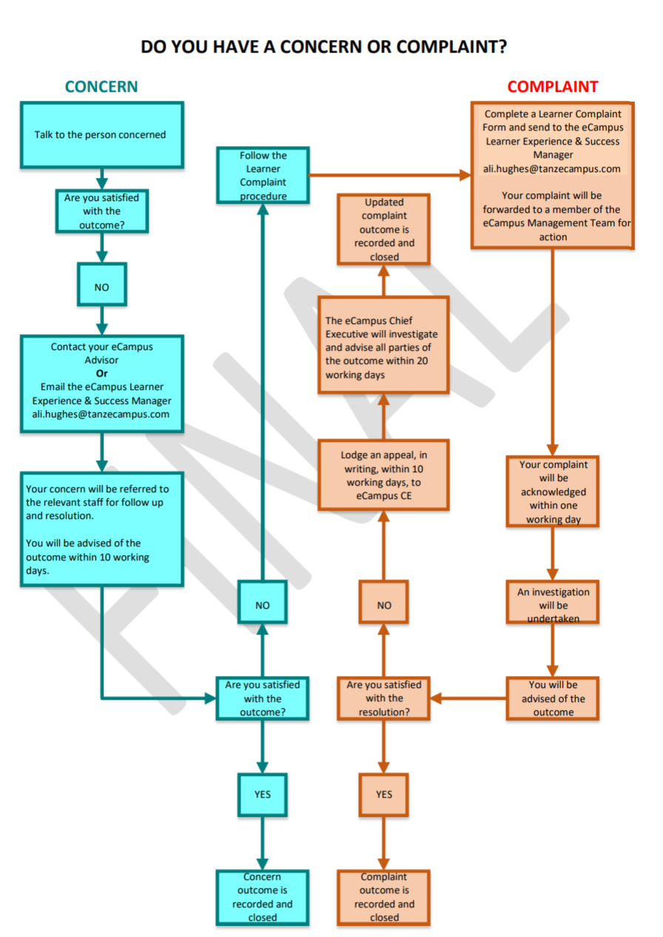

LEARNER COMPLAINT FORM
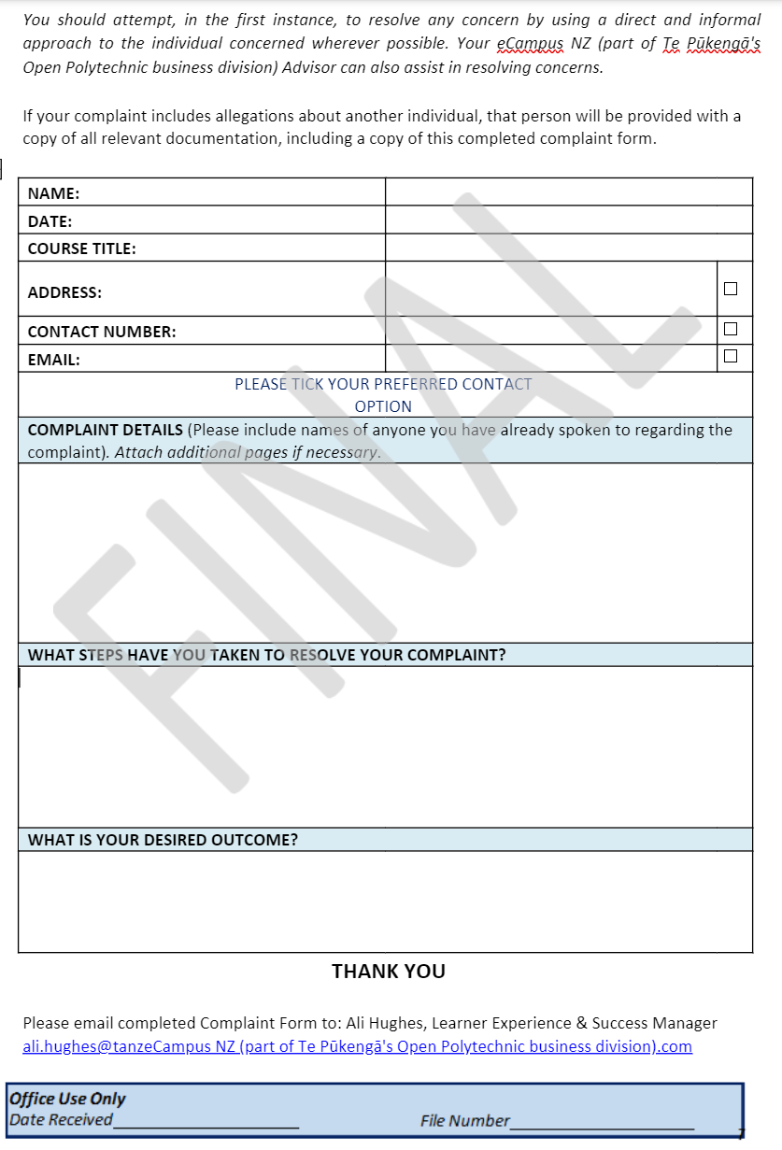

7. References

7.1 Internal
- eCampus NZ Community Code of Conduct Policy
- eCampus NZ Privacy Policy

7.2 External
- The Bill of Rights – Principles of Natural Justice Privacy Act 2020

