First Approved | August 2019 | Initial Approval Body | eCampus NZ
Current Version | February 2023 | Responsibility | Ali Hughes -Learner Experience & Success Manager
Next Review | December 2023

Contents
1. What is meant by compassionate withdrawal? 3
2. Support to consider before applying for withdrawal on compassionate grounds 3
3. Due dates for applying for compassionate withdrawal 3
4. How to apply for a compassionate withdrawal 4
5. Information for international students 5
6. Implications for fees, loans and allowances, and immigration status 5
7. Review of decisions 5
Compassionate Withdrawal form 6

1. What is meant by compassionate withdrawal?
Compassionate withdrawal refers to withdrawal from a course / programme (which may be after the cancellation or withdrawal deadlines), if you are prevented from successfully completing a course(s) due to unexpected circumstances / unplanned events outside your control.
Refunds may be considered for compassionate reasons upon receipt of written evidence which must be submitted by you with the completed ‘Compassionate Withdrawal Form’.
Compassionate grounds are events, occurring in the current occurrence of your course or programme, that are outside your control, that could not have been predicted and that have had a significant impact on your ability to continue studying in your current course or programme for the foreseeable future.
This may include, but not limited to, such things as
- Serious illness or accident, or severe psychological impairment
- Bereavement
- Critical personal circumstances involving the health or wellbeing of a relative
- Sporting/cultural commitments (you must be representing New Zealand, or trialling for New Zealand representation)
- Service in the New Zealand Armed Forces, or other exceptional circumstances beyond your control (e.g., natural disaster, damage to significant property, impacts arising from being the victim of a crime, etc.).
The evidence supplied must be related to the dates of your current course occurrence or programme.
Compassionate grounds will not be considered sufficient for a refund of fees where you could have continued in the course or programme with support or where you have chosen to withdraw for other reasons.

2. Support to consider before applying for withdrawal on compassionate grounds
Before applying for withdrawal from a course or courses on compassionate grounds, it is strongly recommended that you seek support from your Facilitator or Student Advisor to see how they may be able to assist you in completing your courses successfully.

3. Due dates for applying for compassionate withdrawal
The application for compassionate withdrawal with refund should be made at the earliest possible time but must be submitted before the day of the final assessment for the course from which you wish to withdraw. Late applications will not be considered. Supporting documentation must be provided within 14 days of submitting the application (if not already provided when the application was submitted).

4. How to apply for a compassionate withdrawal
To apply for compassionate withdrawal, you need to fill in the “Compassionate Withdrawal Form” and return it to your eCampus NZ (part of Te Pūkengā's Open Polytechnic business division) Student Advisor. Supporting evidence (e.g., a medical certificate) must be provided either with the form or subsequently. You may be asked for additional evidence (if required).
Supporting documentation:
- All applications based on medical impairment (illness, injury or mental health) must be supported by a medical certificate. It is strongly recommended that you see a Health Professional at an appropriate time, i.e. when the symptoms of your illness or injury are apparent. Medical certificates provided on the basis of a consultation after the impairment has passed are not likely to be considered suitable evidence.
- In cases of bereavement, appropriate evidence may include a death notice (an online notification is acceptable). Where the notice does not mention you by name, you should provide a letter from a funeral director, minister of religion, kaumatua/kuia or the police to confirm your relationship with the deceased.
- For all other exceptional cases, the nature of the supporting documentation will depend on the circumstances but might include police reports or a letter from an appropriate third party.
Certificates signed by family members or persons residing in the same household as you are not acceptable All supporting documentation must be written in English or be accompanied by a certified English translation.
If you are unsure of appropriate evidence, contact your Student Advisor for further advice.
Information provided in support of your application will be kept in confidence in accordance with the eCampus NZ (part of Te Pūkengā's Open Polytechnic business division) Privacy policy.
All withdrawals for compassionate consideration will be forwarded to NZIST (Te Pūkenga – New Zealand Institute of Skills and Technology). eCampus NZ is responsible to forwarding all necessary documentation to the enrolling Te Pūkenga subsidiary.
The decision to refund fees on compassionate grounds will take into consideration the length of time you have been enrolled in a programme/course(s).
The final decision is made by your enrolling Te Pūkenga subsidiary and will be made within 10 working days of receiving the recommendation from eCampus NZ (part of Te Pūkengā's Open Polytechnic business division).
The amount of the refund will be at the discretion of your enrolling Te Pūkenga subsidiary Chief Financial Officer (or delegate).
Fees funded by StudyLink will be refunded to StudyLink.
Your enrolling Te Pūkenga subsidiary will let you know of their decision on your compassionate withdrawal application and fees refund.
Your enrolling Te Pūkenga subsidiary will also inform eCampus NZ of their decision on your compassionate withdrawal application, EFTS funding claimed and fees refund

5. Information for international students
If you are an international student, deleting or withdrawing from courses may mean that you no longer fulfil the conditions of your visa. Please speak to Immigration New Zealand or your enrolling Te Pūkenga subsidiary.

6. Implications for fees, loans and allowances, and immigration status
Deleting or withdrawing from courses may have implications for your tuition fees and/or StudyLink loans and allowances. It may also affect the immigration status of international students.

7. Review of decisions
If you are dissatisfied with the outcome of a compassionate withdrawal application, you may request a review of that decision. Such requests must be put in writing and submitted within 10 working days of the communication advising you of the initial decision.
Requests can be submitted:
Via email to Ali Hughes the Learner Experience & Success Manager: ali.hughes@tanzecampus.com
The request should include the grounds for seeking review, considering the information which is provided in this form. You may also provide any additional information that further supports your application.
Review requests will be considered, within 10 working days, by an appropriate party not involved in the original decision.

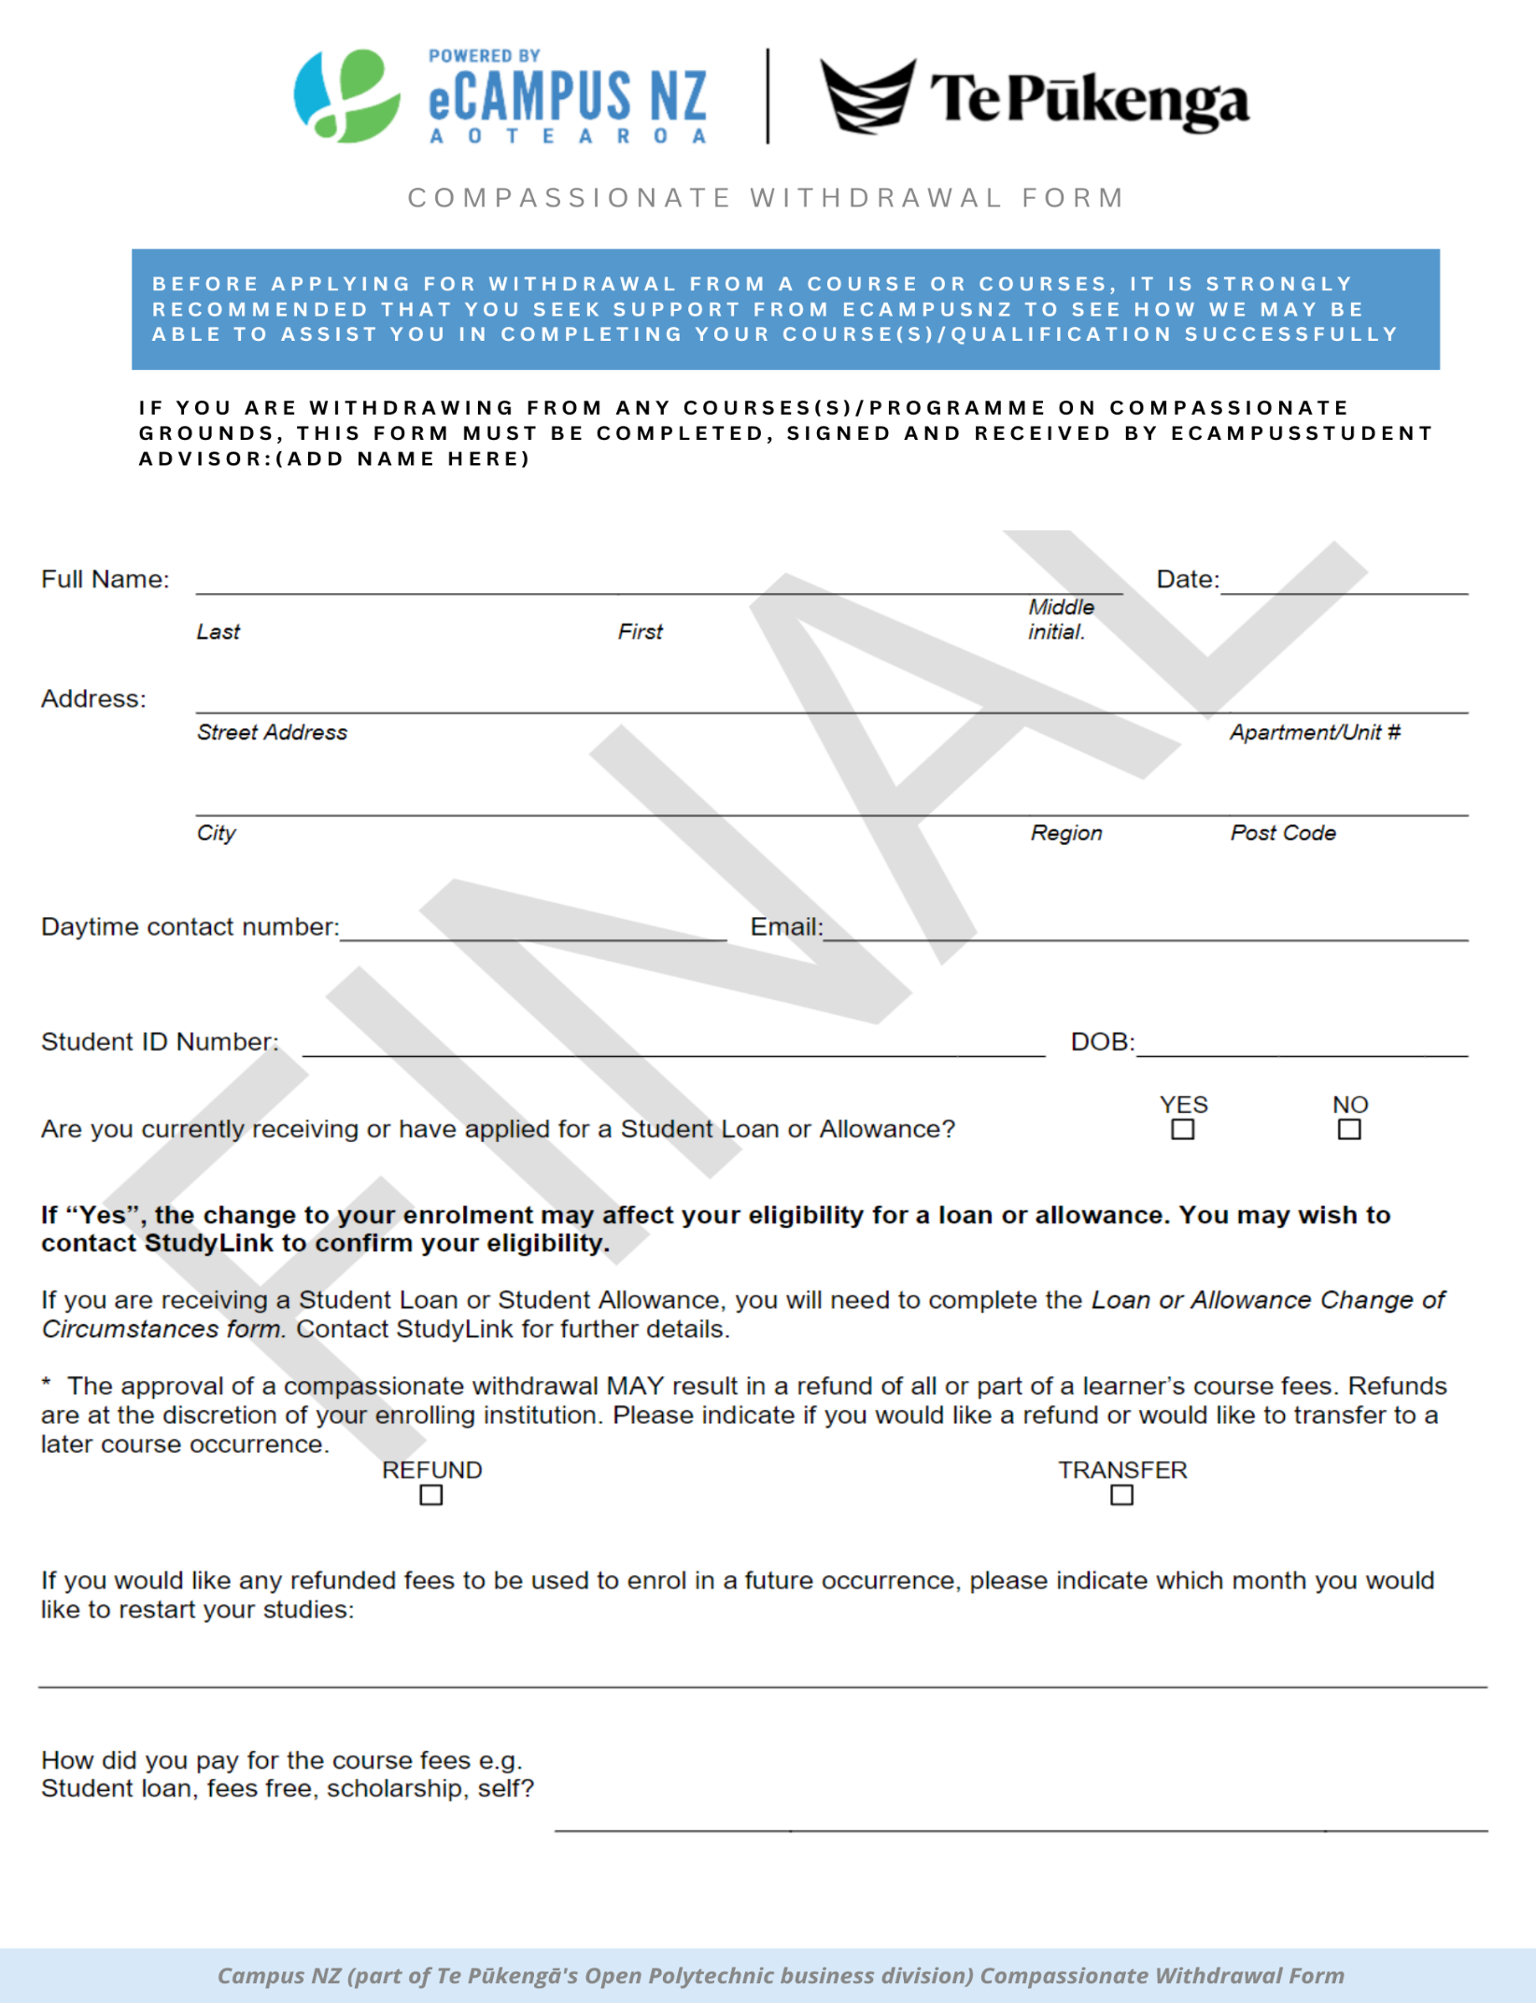

Compassionate Withdrawal form

