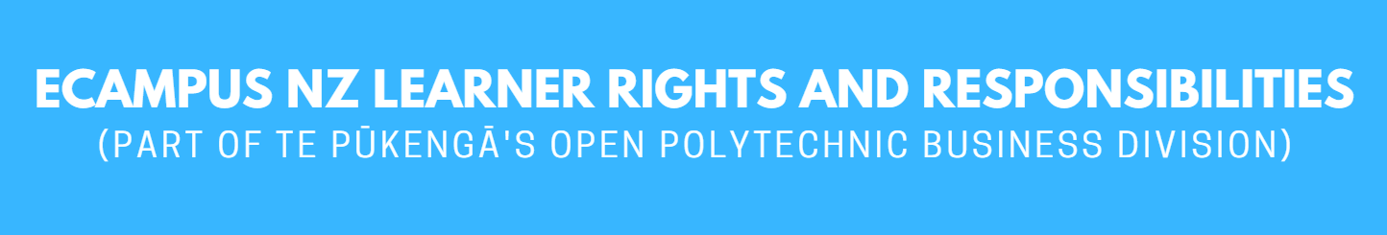

First Approved | January 2015 | Initial Approval Body | eCampus NZ Board
Current Version | February 2023 | Responsibility | Ali Hughes - Learner Experience & Success Manager
Next Review | December 2023

Contents
1. eCampus NZ Learner Rights and Responsibilities 2
2. Your Responsibilities as a Learner 3
3. Unacceptable Behaviour for Learners 3

1. eCampus NZ Learner Rights and Responsibilities
Your rights as a Registered Learner

You are entitled to:
Fairness
- open and accurate information
- fair evaluation and assessment
- problems handled as quickly as practicable and consistent with ‘natural justice’
- personal privacy

Respect
- freedom from any form of harassment or unjust discrimination
- respect for personal, social, and cultural differences

Standards
- programmes and courses that meet internal and external standards for approval and registration
- competent and effective teaching
- appropriate support services, delivered in a professional manner

2. Your Responsibilities as a Learner

You are expected to:
Behave safely
- take precautions so as not to endanger yourself or others

Respect others
- be sensitive to personal, social and cultural differences
- respect the needs, rights, and freedoms of others
- help to uphold the integrity of eCampus NZ (part of Te Pūkengā's Open Polytechnic business division) by discouraging/reporting dishonest practices.
- Observe eCampus NZ (part of Te Pūkengā's Open Polytechnic business division) rules
- behave appropriately for the environment
- endeavour to meet all course requirements
- be honest when completing assignments/other assessments
- follow eCampus NZ (part of Te Pūkengā's Open Polytechnic business division) policies and regulations

3. Unacceptable Behaviour for Learners
Your responsibilities as a learner include behaving in an acceptable manner. The following are not acceptable behaviours:
- breaking any New Zealand law
- any form of cheating (including plagiarism and other dishonest practices)
- misuse of technology, software, hardware, or communication systems provided by eCampus NZ (part of Te Pūkengā's Open Polytechnic business division)
- infringement of copyright (including plagiarism) or software license agreements
- any form of harassment or discrimination

eCampus NZ (part of Te Pūkengā's Open Polytechnic business division) takes this statement of rights and responsibilities seriously.

Infringements will be dealt with under the terms of this policy (refer Policy Infringement section)

